**Project Details**

|  |  |
| --- | --- |
| Project number | *12* |
| Project title | *Mega Store Corporation* |
| Corresponding TA\LA | *TA/Dina Abbas* |
| Deliverable | *Phase 4* |

**Team Details**

|  |  |  |
| --- | --- | --- |
| **Student ID** | **Student name** | **Lab Group** |
| 20200076 | Esraa Mohamed Abdel satar | S3 |
| 20201024 | Alaa essam ali | S5 |
| 20201202 | Norhan Hassan Ali Elsadiq | S7 |
| 20200618 | Hala Gamal Meselhy | S4 |
| 20200599 | Nagham hassan abu elfath | S7 |
| 20200093 | Omnya alaa korany | S8 |
| 20201178 | Mennat allah Mohamed Ibrahim el sharawy | S7 |

**Phase 4: Use case Realization**

1. CRC for add offers use case:

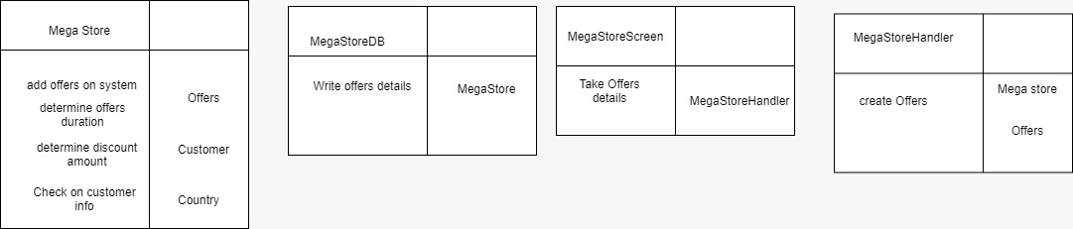

-1-1**partial class diagram for add offers use case in CRC**

1. 2-1 CRC for buy product use case

1. **2-2partial class diagram for Payment use case in CRC diagram**

* Communication Diagram for Add offers use case

- Communication Diagram for Buy product use case

* Partial class diagram for buy product use case in communication diagram

Select two complex use cases:

* Generate and draw a **partial class diagram** using **multi-layer sequence diagram** .

1. Class diagram for sequence 1

1. Class diagram for sequence 2

1. Generate and draw **final-cut class diagram** output from 1.a, 1.b, and 2 [**Fully-defined attributes and methods, navigation, multiplicity**].

1. Generate and draw **package diagram** from the resulted detailed class diagram in 3.

